Project Proposal of Applied Physics
(Development of Speed Detector)

Group Members: Registration No:
- Syed Muhammad Ahmad Shah. (B24F0178AI053)
- Razi Abdullah. (B24F0068AI080)
- Muhammad Saim Sabir. (B24F0998AI084)
- Muhammad Bilal. (B24F1007AI081)
- Abdullah Iftikhar. (B24F1224AI056)
Semester Number:
First Semester.
Department:
Artificial Intelligence.
Teacher:
Dr. Zuhair.
Lab Engineer:
Aymen Jamil.

Introduction:
The ability to measure speed accurately is a critical aspect of modern technology, serving a variety of fields such as transportation, sports, law enforcement, and industrial automation. Speed detectors play an essential role in ensuring road safety by monitoring vehicle speeds, optimizing performance in athletic events, and enhancing efficiency in automated systems. They operate on the fundamental principles of physics, primarily focusing on motion, distance, and time measurement.
Over the years, technological advancements have revolutionized the methods of speed detection, ranging from basic mechanical tools to sophisticated systems like radar, laser sensors, and GPS-based tracking. Infrared and ultrasonic sensors have added precision and flexibility, enabling speed detectors to measure velocity with remarkable accuracy across diverse environments. These devices are now indispensable in managing traffic, improving safety, and supporting scientific research.
This project is an exploration into the development and functionality of a basic speed detector, aiming to showcase the practical application of physics in everyday scenarios. The design uses simple yet effective tools to measure the velocity of moving objects, providing a hands-on understanding of the principles behind speed measurement. By working on this project, we aim to highlight how fundamental scientific concepts can be combined with modern technology to create practical and impactful solutions for real-world challenges.
Required Components:
- Arduino.
- Push button.
- Buzzer.
- 16 X 2 LCD.
- 2 IR Sensor.
- Battery 9 volt.
- 2 bread boards.
- 100Ω resistor.
- 4.7kΩ resister.
- 1kΩ resister.
- 10 male to male jumper wires.
Working Principle:
The working principle of a speed detector is based on the fundamental relationship between distance, time, and speed, given by the formula Speed=Distance\Time​. The device calculates speed by measuring the time taken for an object to travel a known distance. Depending on the type of speed detector, different methods are used to gather this data. For instance, light gates or infrared sensors detect when an object passes through their beam, recording the time it interrupts two fixed sensors placed at a known distance apart. The difference in time, combined with the distance, allows the calculation of the object’s speed. Radar-based detectors, on the other hand, utilize the Doppler Effect, where radio waves emitted by the detector reflect off the moving object. By analyzing the shift in frequency of the reflected waves, the device determines the object's velocity. Similarly, ultrasonic speed detectors emit high-frequency sound waves, measuring the time it takes for the echo to return, or the frequency shift caused by the moving object. Lidar (laser) speed detectors use precise laser beams to calculate the time of flight for the beam to hit and return from the object, using this data to determine speed. All these technologies rely on accurate timing and distance measurement, often enhanced by computational algorithms, to ensure reliable and efficient speed detection.
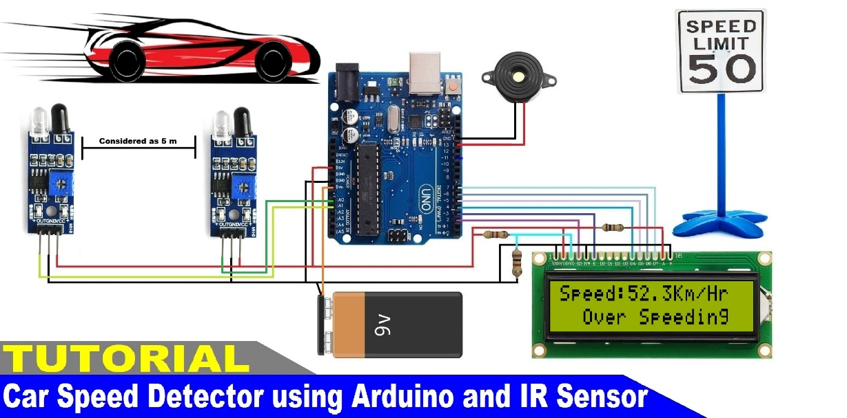
Circuit Diagram of speed detector:

Arduino Code:
#include <LiquidCrystal.h>
LiquidCrystal lcd(7, 8, 9, 10, 11, 12);
const int sensor1Pin = 2;
const int sensor2Pin = 3;
volatile unsigned long timeSensor1 = 0;
volatile unsigned long timeSensor2 = 0;
const float distance = 0.5;
void setup() {
lcd.begin(16, 2);
lcd.print("Speed Detector");
pinMode(sensor1Pin, INPUT);
pinMode(sensor2Pin, INPUT);
attachInterrupt(digitalPinToInterrupt(sensor1Pin), sensor1Triggered, RISING);
attachInterrupt(digitalPinToInterrupt(sensor2Pin), sensor2Triggered, RISING);
delay(1000);
}
void loop() {
if (timeSensor1 > 0 && timeSensor2 > 0) {
unsigned long timeDifference = timeSensor2 - timeSensor1;
float timeInSeconds = timeDifference / 1e6;
float speed = distance / timeInSeconds;
lcd.clear();
lcd.print("Speed: ");
lcd.print(speed);
lcd.print(" m/s");

timeSensor1 = 0;
timeSensor2 = 0;
delay(2000);
}
}
void sensor1Triggered() {
timeSensor1 = micros();
}
void sensor2Triggered() {
timeSensor2 = micros();
}
Applications of Proposed System:
- Traffic Monitoring:
- Measuring vehicle speeds on roads to enforce speed limits.
- Detecting speeding vehicles for law enforcement purposes.
- Industrial Automation:
- Monitoring the speed of conveyor belts in production lines.
- Ensuring consistent speeds for packaging or sorting systems.
- Sports and Fitness:
- Measuring the speed of balls, runners, or vehicles in sports.
- Tracking athletes' performance in races or training sessions.
- Transportation Systems:
- Monitoring train or tram speeds for safety and efficiency.
- Ensuring adherence to speed regulations in automated transport systems.
- Research and Development:
- Testing prototypes of vehicles or machinery under controlled speed conditions.
- Conducting studies on aerodynamic properties or motion dynamics.
- Educational Purposes:
- Demonstrating principles of motion and speed measurement in classrooms.
- Building low-cost speed measurement devices for academic projects.
- Safety and Security:
- Monitoring equipment speed to prevent machinery overuse or failure.
- Detecting unauthorized or unsafe movement in restricted areas.

